SQL QUERY FOR GOODCABS PROJECT

1. 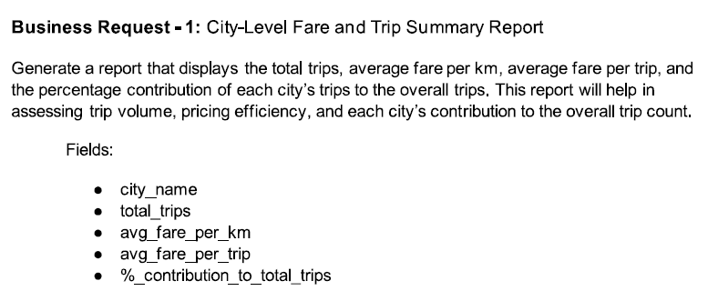

Ans SELECT

dc.city_name,

COUNT(ft.trip_id) AS Total_trip,

ROUND(SUM(ft.fare_amount) / SUM(ft.distance_travelled_km), 2) AS Avg_fare_per_km,

ROUND(SUM(ft.fare_amount) / COUNT(ft.trip_id), 2) AS Avg_fare_per_trip,

ROUND((COUNT(ft.trip_id) * 100.0) / (SELECT COUNT(trip_id) FROM fact_trips), 2) AS Total_trip_percentage

FROM

fact_trips ft

JOIN

dim_city dc

ON

dc.city_id = ft.city_id

GROUP BY

dc.city_name;

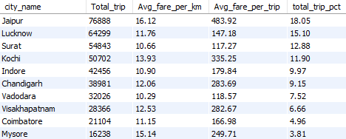

1. 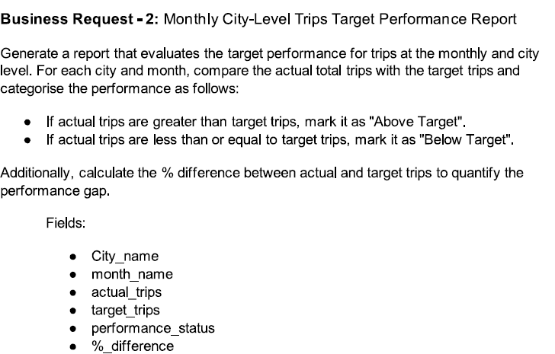

Ans -- Step 1: Actual trip counts per city and month

WITH actual AS (

SELECT

dc.city_id,

dc.city_name,

MONTHNAME(ft.date) AS monthy,

COUNT(ft.trip_id) AS total_trip

FROM

fact_trips ft

JOIN

dim_city dc

ON

ft.city_id = dc.city_id

GROUP BY

dc.city_id, dc.city_name, MONTHNAME(ft.date)

),

-- Step 2: Target trip counts per city and month

target AS (

SELECT

dc.city_id,

dc.city_name,

MONTHNAME(tt.month) AS monthy,

tt.total_target_trips AS target_trip

FROM

monthly_target_trips tt

JOIN

dim_city dc

ON

tt.city_id = dc.city_id

GROUP BY

dc.city_id, dc.city_name, MONTHNAME(tt.month), tt.total_target_trips

ORDER BY

dc.city_id ASC

)

-- Step 3: Comparing actual and target trips

SELECT

actual.city_name,

actual.monthy,

actual.total_trip,

target.target_trip,

CASE

WHEN actual.total_trip < target.target_trip THEN 'Below Target'

ELSE 'Above Target'

END AS performance,

CONCAT(

ROUND((actual.total_trip - target.target_trip) * 100 / target.target_trip, 2), '%'

) AS pct_difference

FROM

actual

JOIN

target

ON

target.city_id = actual.city_id

AND target.monthy = actual.monthy;

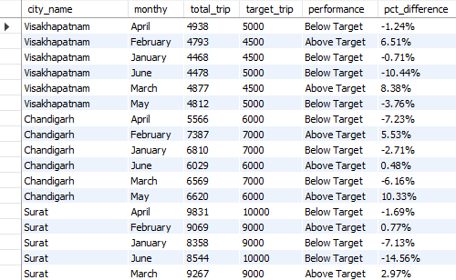

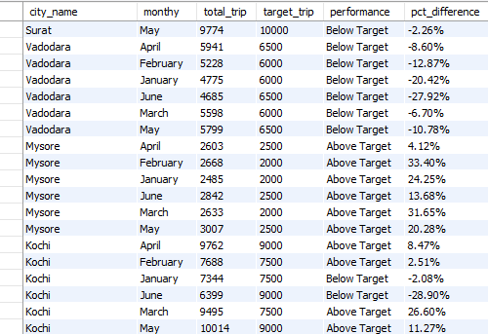

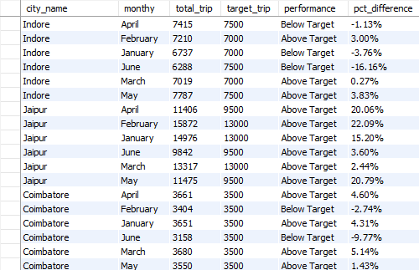

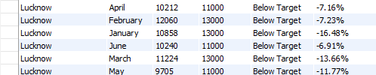

1. 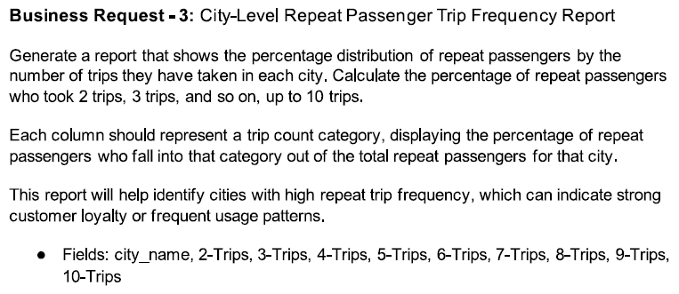

Ans with cte1 as (SELECT

dc.city_id,

dc.city_name,

SUM(rt.repeat_passenger_count) AS Total_Trips,

SUM(CASE WHEN rt.trip_count = '2-Trips' THEN rt.repeat_passenger_count ELSE 0 END) AS Trip2_Count,

ROUND(

100.0 * SUM(CASE WHEN rt.trip_count = '2-Trips' THEN rt.repeat_passenger_count ELSE 0 END)

/ SUM(rt.repeat_passenger_count), 0

) AS Trip2_Percentage,

SUM(CASE WHEN rt.trip_count = '3-Trips' THEN rt.repeat_passenger_count ELSE 0 END) AS Trip3_Count,

ROUND(

100.0 * SUM(CASE WHEN rt.trip_count = '3-Trips' THEN rt.repeat_passenger_count ELSE 0 END)

/ SUM(rt.repeat_passenger_count), 0

) AS Trip3_Percentage,

SUM(CASE WHEN rt.trip_count = '4-Trips' THEN rt.repeat_passenger_count ELSE 0 END) AS Trip4_Count,

ROUND(

100.0 * SUM(CASE WHEN rt.trip_count = '4-Trips' THEN rt.repeat_passenger_count ELSE 0 END)

/ SUM(rt.repeat_passenger_count), 0

) AS Trip4_Percentage,

SUM(CASE WHEN rt.trip_count = '5-Trips' THEN rt.repeat_passenger_count ELSE 0 END) AS Trip5_Count,

ROUND(

100.0 * SUM(CASE WHEN rt.trip_count = '5-Trips' THEN rt.repeat_passenger_count ELSE 0 END)

/ SUM(rt.repeat_passenger_count), 0

) AS Trip5_Percentage,

SUM(CASE WHEN rt.trip_count = '6-Trips' THEN rt.repeat_passenger_count ELSE 0 END) AS Trip6_Count,

ROUND(

100.0 * SUM(CASE WHEN rt.trip_count = '6-Trips' THEN rt.repeat_passenger_count ELSE 0 END)

/ SUM(rt.repeat_passenger_count), 0

) AS Trip6_Percentage,

SUM(CASE WHEN rt.trip_count = '7-Trips' THEN rt.repeat_passenger_count ELSE 0 END) AS Trip7_Count,

ROUND(

100.0 * SUM(CASE WHEN rt.trip_count = '7-Trips' THEN rt.repeat_passenger_count ELSE 0 END)

/ SUM(rt.repeat_passenger_count), 0

) AS Trip7_Percentage,

SUM(CASE WHEN rt.trip_count = '8-Trips' THEN rt.repeat_passenger_count ELSE 0 END) AS Trip8_Count,

ROUND(

100.0 * SUM(CASE WHEN rt.trip_count = '8-Trips' THEN rt.repeat_passenger_count ELSE 0 END)

/ SUM(rt.repeat_passenger_count), 0

) AS Trip8_Percentage,

SUM(CASE WHEN rt.trip_count = '9-Trips' THEN rt.repeat_passenger_count ELSE 0 END) AS Trip9_Count,

ROUND(

100.0 * SUM(CASE WHEN rt.trip_count = '9-Trips' THEN rt.repeat_passenger_count ELSE 0 END)

/ SUM(rt.repeat_passenger_count), 0

) AS Trip9_Percentage,

SUM(CASE WHEN rt.trip_count = '10-Trips' THEN rt.repeat_passenger_count ELSE 0 END) AS Trip10_Count,

ROUND(

100.0 * SUM(CASE WHEN rt.trip_count = '10-Trips' THEN rt.repeat_passenger_count ELSE 0 END)

/ SUM(rt.repeat_passenger_count), 0

) AS Trip10_Percentage

FROM

dim_repeat_trip_distribution rt

JOIN

dim_city dc ON dc.city_id = rt.city_id

GROUP BY

dc.city_id,

dc.city_name

ORDER BY

Total_Trips DESC)

select city_id,city_name,Total_Trips,concat(Trip2_Percentage,'%')as Trips_2_pct,

concat(Trip3_Percentage,'%')as Trips_3_pct,concat(Trip4_Percentage,'%')as Trips_4_pct,

concat(Trip5_Percentage,'%')as Trips_5_pct,concat(Trip6_Percentage,'%')as Trips_6_pct,

concat(Trip7_Percentage,'%')as Trips_7_pct,concat(Trip8_Percentage,'%')as Trips_8_pct,

concat(Trip9_Percentage,'%')as Trips_9_pct,concat(Trip10_Percentage,'%')as Trips_10_pct

from cte1

order by total_trips desc

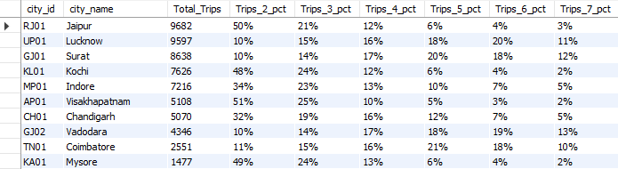 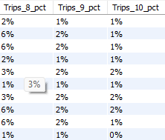

1. 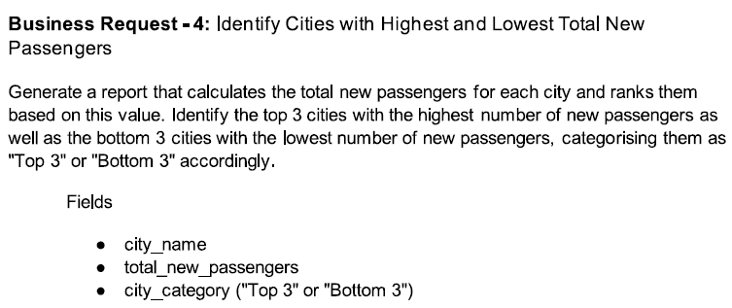

Ans WITH ranked_passengers AS (

SELECT

dc.city_name,

SUM(ps.new_passengers) AS total_new_passenger,

RANK() OVER (ORDER BY SUM(ps.new_passengers) DESC) AS rank_desc,

RANK() OVER (ORDER BY SUM(ps.new_passengers) ASC) AS rank_asc

FROM

fact_passenger_summary ps

JOIN

dim_city dc

ON

dc.city_id = ps.city_id

GROUP BY

dc.city_name

)

SELECT

city_name,

total_new_passenger,

CASE

WHEN rank_desc <= 3 THEN 'Top 3'

WHEN rank_asc <= 3 THEN 'Bottom 3'

END AS city_category

FROM

ranked_passengers

WHERE

rank_desc <= 3 OR rank_asc <= 3

ORDER BY

total_new_passenger DESC;

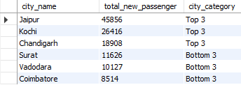

1. 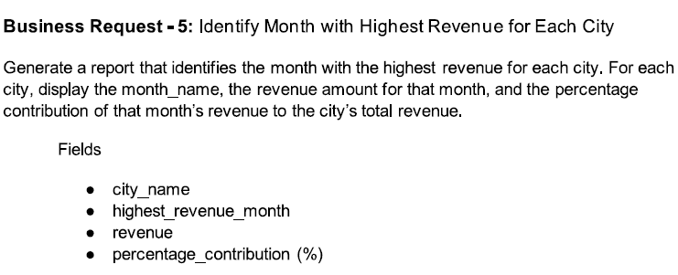

Ans WITH cte1 AS (

SELECT

dc.city_name,

MONTHNAME(ft.date) AS Month,

SUM(ft.fare_amount) AS total_revenue,

DENSE_RANK() OVER (PARTITION BY dc.city_name ORDER BY SUM(ft.fare_amount) DESC) AS Ranke

FROM

fact_trips ft

JOIN

dim_city dc

ON

ft.city_id = dc.city_id

GROUP BY

dc.city_name, Month

),

cte2 AS (

SELECT

cte1.city_name,

cte1.Month,

cte1.total_revenue AS Highest_revenue

FROM

cte1

WHERE

cte1.Ranke = 1

),

cte3 AS (

SELECT

city_name,

SUM(total_revenue) AS total_city_revenue

FROM

cte1

GROUP BY

city_name

)

SELECT

cte2.city_name,

cte2.Month,

cte2.highest_revenue,

concat (round((cte2.highest_revenue * 100.0 / cte3.total_city_revenue),2),'%') AS Pct_Distribution

FROM

cte2

JOIN

cte3

ON

cte2.city_name = cte3.city_name;

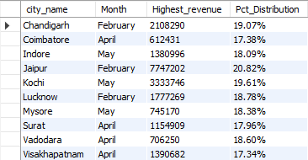

1. 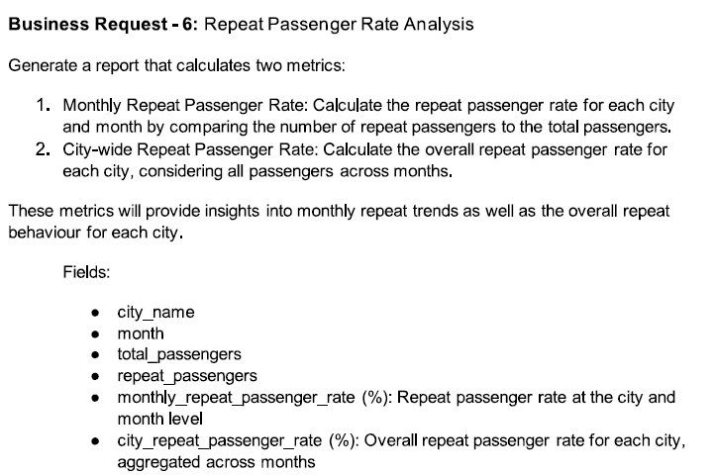

Ans WITH cte1 AS (

SELECT

dc.city_name,

MONTHNAME(ps.month) AS Month,

SUM(ps.total_passengers) AS Total_Passenger,

SUM(ps.repeat_passengers) AS Total_Repeat,

CONCAT(ROUND(SUM(ps.repeat_passengers) * 100 / SUM(ps.total_passengers), 2), '%') AS Monthly_Repeat_Passenger_Rate

FROM

fact_passenger_summary ps

JOIN

dim_city dc

ON

ps.city_id = dc.city_id

GROUP BY

dc.city_name, MONTHNAME(ps.month)

),

cte2 AS (

SELECT

dc.city_name,

SUM(ps.total_passengers) AS Total_Passenger,

SUM(ps.repeat_passengers) AS Total_Repeat,

CONCAT(ROUND(SUM(ps.repeat_passengers) * 100 / SUM(ps.total_passengers), 2), '%') AS City_Repeat_Passenger_Rate

FROM

fact_passenger_summary ps

JOIN

dim_city dc

ON

ps.city_id = dc.city_id

GROUP BY

dc.city_name

)

SELECT

cte1.city_name,

cte1.Month,

cte1.Total_Passenger,

cte1.Total_Repeat,

cte1.Monthly_Repeat_Passenger_Rate,

cte2.City_Repeat_Passenger_Rate

FROM

cte1

JOIN

cte2

ON

cte1.city_name = cte2.city_name

;

